1. VPC NETWORKING

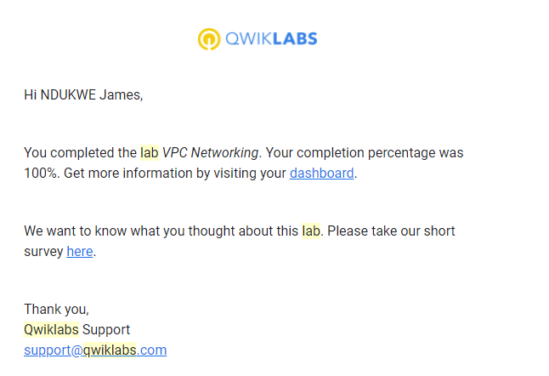

1. CONSOLE AND CLOUD SHELL

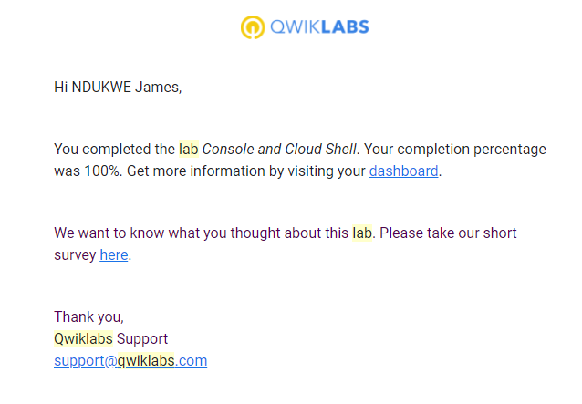

3 . INFRASTRUCTURE PREVIEW

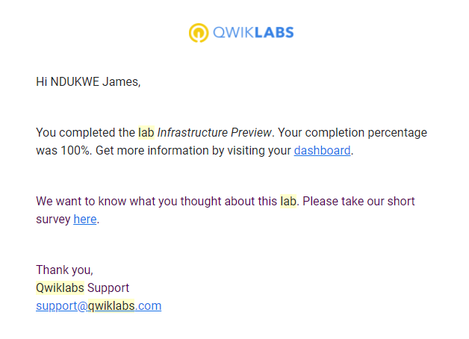

4. Google Cloud Fundamentals: Getting Started with GKE.

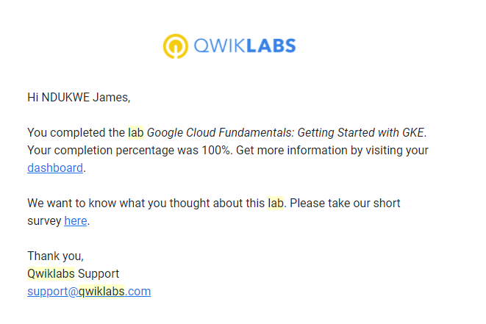

5. Google Cloud Fundamentals: Getting Started with Cloud Marketplace

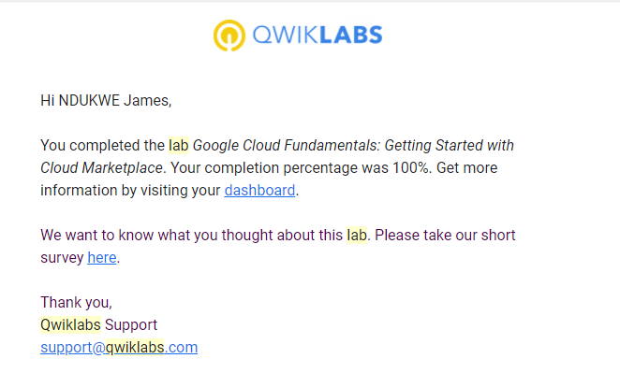

6. Google Cloud Fundamentals: Getting Started with Cloud Storage and Cloud SQL.

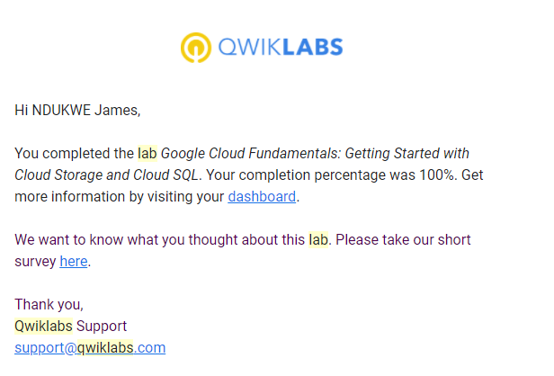

7. Getting Started with Compute Engine.

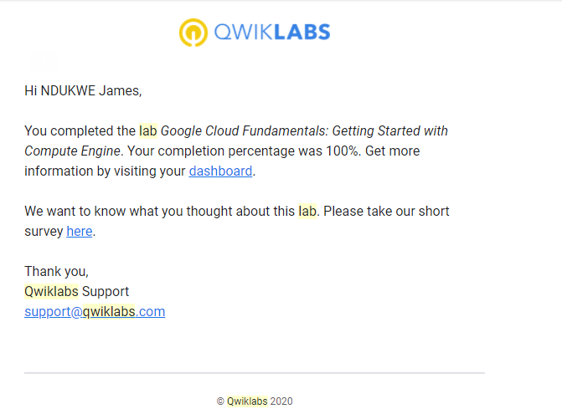

8.

**SECOND CHALLENGE**

# Google Cloud Fundamentals: Getting Started with Compute Engine : CLI

1.gcloud init

1.gcloud compute zones list | grep us-central1

2.gcloud config set compute/zone us-central1-b

3.gcloud compute instances create "my-vm-1" \

4.--machine-type "n1-standard-1" \

5.--image-project "debian-cloud" \

6.--image "debian-9-stretch-v20190213" \

7.--subnet "default"

8.gcloud compute instances create "my-vm-2" \

9.--machine-type "n1-standard-1" \

10.--image-project "debian-cloud" \

11.--image "debian-9-stretch-v20190213" \

12.--subnet "default"

13.ping my-vm-1

14. ssh my-vm-1

15. sudo apt-get install nginx-light -y

16. sudo nano /var/www/html/index.nginx-debian.html

17. Hi from YOUR_NAME

18. curl http://localhost/

19. exit

20. curl http://my-vm-1/

# 2.Google Cloud Fundamentals: Getting Started with App Engine :CLI

1. gcloud init
2. gcloud app create --project=$DEVSHELL_PROJECT_ID
3. git clone https://github.com/GoogleCloudPlatform/python-docs-samples
4. cd python-docs-samples/appengine/standard_python37/hello_world
5. cd ~/python-docs-samples/appengine/standard_python37/hello_world
6. gcloud app deploy
7. gcloud app deploy

Copy and paste the URL into a new browser window.